**Programming** in the realm of technology refers to the **process of creating instructions** for computers to execute. It’s like providing a recipe to a machine, where the more complex the instructions, the more intricate the result! Now, let’s explore some free resources to kickstart your programming journey:

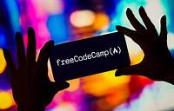

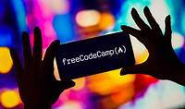

1. [**freeCodeCamp**](https://www.freecodecamp.org/): A donor-supported organization offering free coding education.

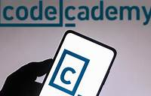

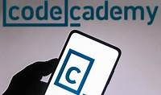

1. [**Codecademy**](https://www.codecademy.com/): Millions learn to code here with interactive courses.
2. [**Programiz**](https://www.programiz.com/): Beginner-friendly tutorials covering Python, SQL, HTML, JavaScript, and more.
3. **CodeWars**: Gamified coding challenges to enhance your skills.



1. **Harvard University’s Edx CS50**: Dive into computer science with this renowned course.

Happy coding! 🚀👩‍💻